Launch one Linux instance in aws.

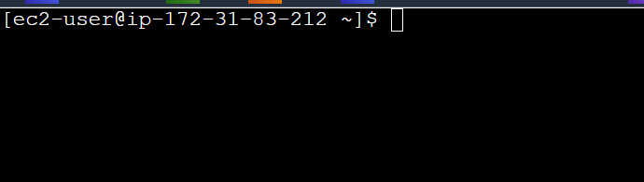

Create on file with name Techie_horizon

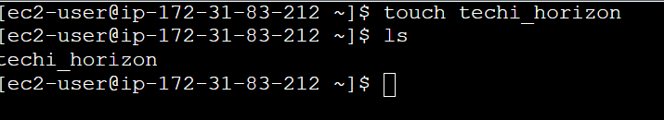

Copy the file "Techie_Horizon" from aws instance to windows machine.





Install Jenkins in the server created in step 1.

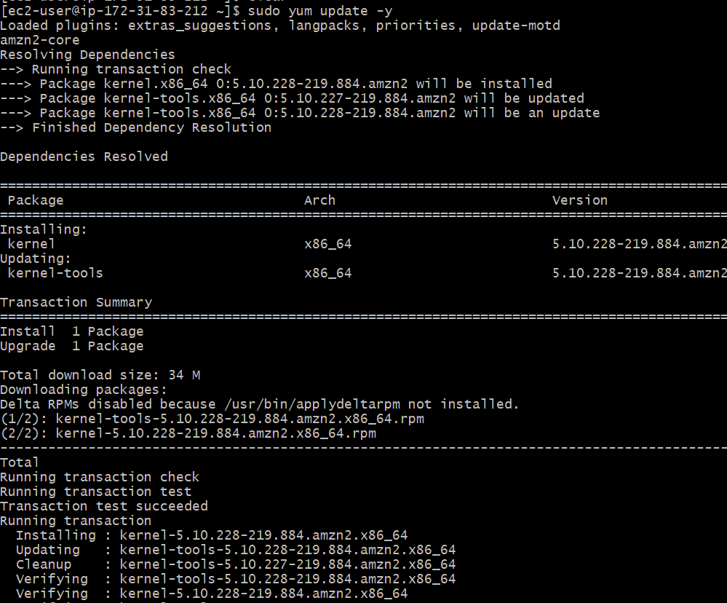



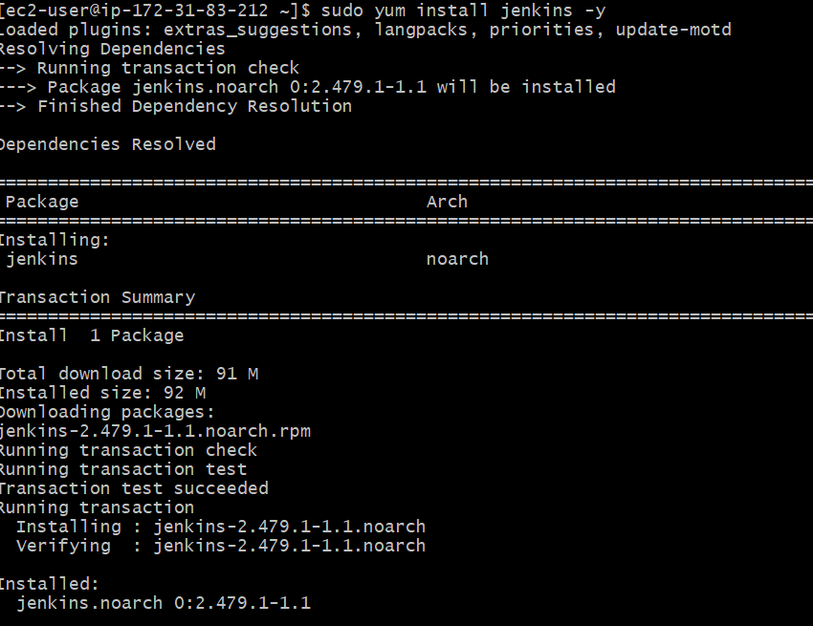

Install httpd,nginx,Apache Tomcat.

nginx

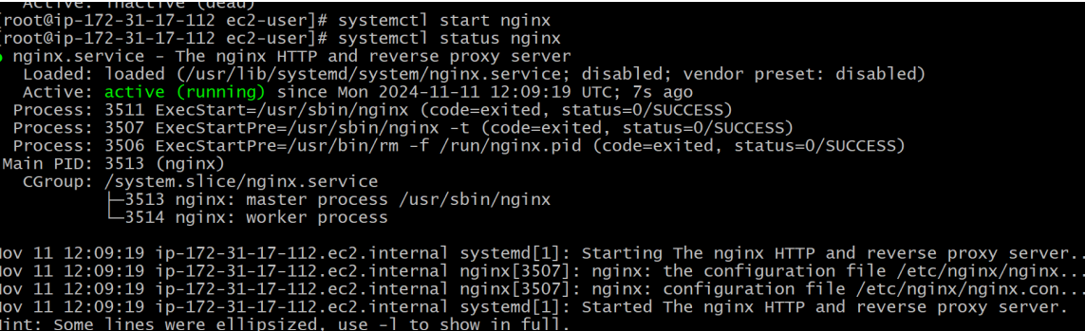

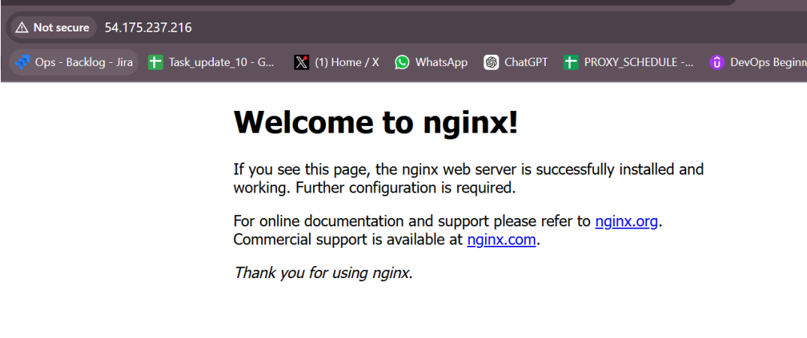

Httpd

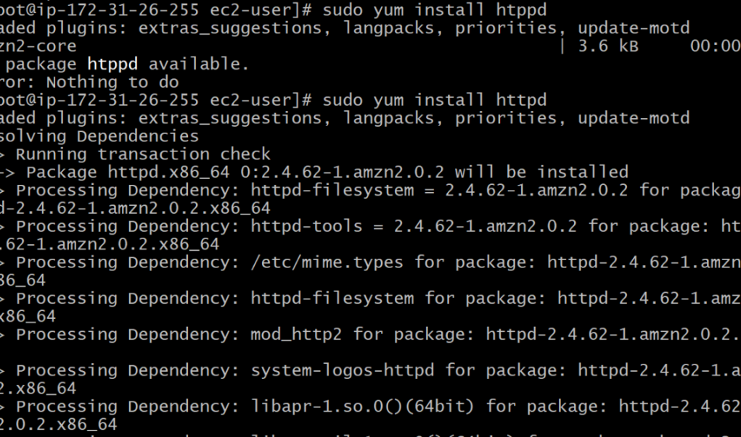

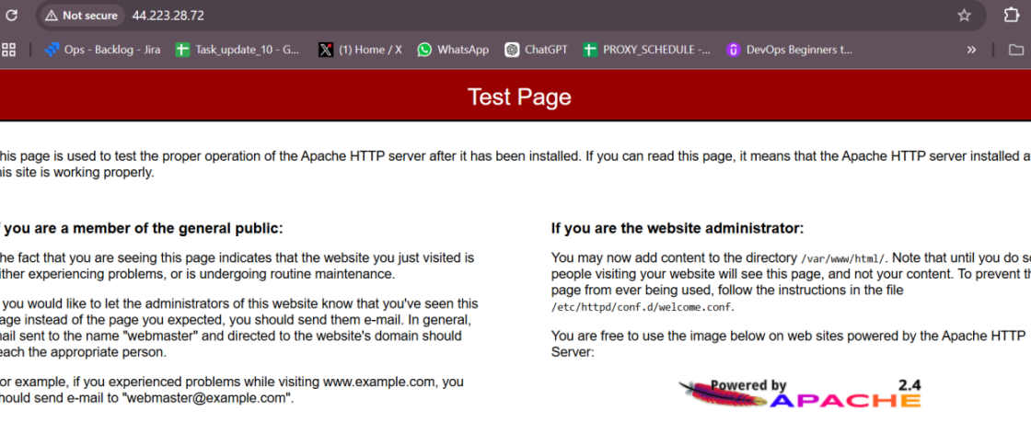

Tomcat:

